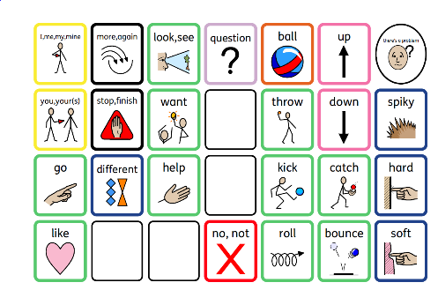Communication Boards

It is important to note:

Communication Boards will only encourage talking if talking is going to develop.   
They will not prevent your child from talking.

Communication Boards will help children to have successful communication if:

* Their speech is unclear
* They don’t have the words to say what they want

Communication Boards can support children to:

* Understand
* Concentrate
* Interact with others
* improve their memory

Children should not be placed under any pressure to use the boards initially but rather the expectation is placed upon the adult to model.



Please scan the QR code to take you to  
the workshop to learn how best to use   
Communication Boards:

**Will an Augmentative Alternative Communication Device Prevent a Child from Speaking?**

In short, no!  This is a common concern of parents and educators working with children who aren’t yet speaking.  Fortunately, much research has been done in this area and it has been found that using AAC systems and devices does not prevent children from learning to speak.  In fact, it can actually help them learn to speak more quickly because it relieves the pressure of speech since they know they have a backup way of communicating if their speech isn’t sufficient.

(Speechandlanguagekids.com – 2023)