  - NHS Equality Delivery System 2022

EDS Reporting Template
Version 1, 15 August 2022

Classification: Official
Publication approval reference:

Contents
Equality Delivery System for the NHS 2

Equality Delivery System for the NHS
The EDS Reporting Template

Implementation of the Equality Delivery System (EDS) is a requirement on both NHS commissioners and NHS providers. Organisations are encouraged to follow the implementation of EDS in accordance EDS guidance documents. The documents can be found at: www.england.nhs.uk/about/equality/equality-hub/patient-equalities-programme/equality-frameworks-and-information-standards/eds/
The EDS is an improvement tool for patients, staff and leaders of the NHS. It supports NHS organisations in England - in active conversations with patients, public, staff, staff networks, community groups and trade unions - to review and develop their approach in addressing health inequalities through three domains: Services, Workforce and Leadership. It is driven by data, evidence, engagement and insight.
The EDS Report is a template which is designed to give an overview of the organisation’s most recent EDS implementation and grade. Once completed, the report should be submitted via england.eandhi@nhs.net and published on the organisation’s website.

Name of Organisation |  | Kent Community Health NHS Foundation Trust | Organisation Board Sponsor/Lead
 |  |  | Chair of Kent Community Health NHS Foundation Trust board
Name of Integrated Care System |  | Kent and Medway ICS

NHS Equality Delivery System (EDS)

EDS Lead | Health Inequalities Team Domain 1, Health and Wellbeing Lead for Domain 2 and Head of Workforce Equity, Diversity and Inclusion for Domain 3. |  | At what level has this been completed?
 |  |  |  | *List organisations
EDS engagement date(s) | September and October 2023 (Domains 1) |  | Individual organisation | Kent Community Health NHS Foundation Trust
 |  |  | Partnership* (two or more organisations) | East Kent VCSE Alliance, West Kent Health and Care VCSE Alliance
 |  |  | Integrated Care System-wide*

Date completed |  | Month and year published | February 2024
Date authorised |  | Revision date

Completed actions from previous year
Action/activity | Related equality objectives
- Review project aims (Healthy Communities project now Healthy Communities Steering Group). | To work with other NHS organisations, the voluntary sector and local authority to engage with people in order to promote health improvement and reduce health inequalities. This includes working with young people, people who are from Black, Asian and minority ethnic (BAME) communities, disabled people, LGBTQ people and carers.
- Patient surveys to move into EDI portfolio. | Using co-design principles to work with our patients and their families, our staff, other NHS organisations and the voluntary sector in order to improve access to services and patient and family experience of health care.
- Develop action plan to engage with services across all of KCHFT.  - Produce datasets to identify completeness of equality monitoring across all services on RIO.  - Review DNA (did not attend) rates and RTT breaches broken down by Ethnicity, Disability, age group, gender, Sexual Orientation (Report in EDS2).  - Complete review of service level completeness of data by geographic location broken down by Ethnicity, Disability, age group, gender, Sexual Orientation (reported in EDS2).  - Progress report on 2018-2021 Equality Objectives sent to Executive Board.  - Equality monitoring questions added to all patient surveys.  - First Cultural safety Training session delivered.  - Develop Guidance to support staff conducting EqIAs (Equality Impact Assessments).  - Recommendations to the Executives on new process for conducting, monitoring and managing EqIAs along with draft proposal for new EqIA form.  - Review of current procedure and quality of Equality Impact Assessments. | To ensure that equality and diversity is embedded in the business of KCHFT.

EDS Rating and Score Card

Please refer to the Rating and Score Card supporting guidance document before you start to score. The Rating and Score Card supporting guidance document has a full explanation of the new rating procedure, and can assist you and those you are engaging with to ensure rating is done correctly

Score each outcome. Add the scores of all outcomes together. This will provide you with your overall score, or your EDS Organisation Rating. Ratings in accordance to scores are below
Undeveloped activity – organisations score out of 0 for each outcome | Those who score under 8, adding all outcome scores in all domains, are rated Undeveloped
Developing activity – organisations score out of 1 for each outcome | Those who score between 8 and 21, adding all outcome scores in all domains, are rated Developing
Achieving activity – organisations score out of 2 for each outcome | Those who score between 22 and 32, adding all outcome scores in all domains, are rated Achieving
Excelling activity – organisations score out of 3 for each outcome | Those who score 33, adding all outcome scores in all domains, are rated Excelling

Domain 1: Commissioned or provided services
Below is a summary of evidence in respect of commissioned or provided services for Domain 1. This should be read with the executive summary for Domain 1 case study which has full details about methodology and service choice. Individual service reports available for Domain 1 upon request from the Health Inequalities Team by e-mailing: kentchft.equality@nhs.net
Domain | Outcome | Evidence | Rating | Owner (Dept/Lead)
Domain 1: Commissioned or provided services | 1A: Patients (service users) have required levels of access to the service | Cardiac Rehabilitation service  - Patients report that the service is very convenient and that they have had access to everything they have needed.  - One patient reported having issues reaching the Nurse in the beginning.  - One patient reported not understanding that support varies from person to person.  - Interpreting over the phone was stated as an issue by staff due to the loss of non-verbal cues.  - Some staff felt that the service is as accessible as it can be.  - The service is looking into a mobile app in addition to the online videos already in place to offer support in areas where there are gaps.  - Issues with getting venues at short notice was mentioned by some staff members leading to booking venues which are less than ideal.  - Some issues reported around the Trust process for consent to receive e-mails.  - It was observed that a patient was offered telephone appointment despite having hearing difficulties.  Cardiac Rehabilitation service datasets  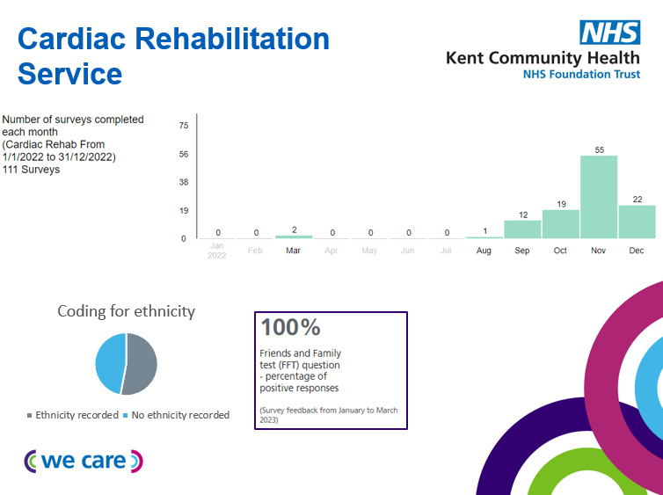  In conclusion access was considered by patients to be excellent. A small issue was raised around availability of a nurse to speak to but this was satisfactorily resolved. Home visits are also already in place as an option within the service for patients with mobility or sensory difficulties. The process around seeking consent for communications was cited by staff as an issue but this is already being looked into at a Trust wide level. One staff member also identified a significant gap in provision in the Thanet area but the service had already identified an innovative way of resolving this through implementation of a mobile app.  The service lead was also offered further support from the Health Inequalities Team around support with finding suitable venues and the offer of the use of the Public Health Bus to reach people in more isolated or less well served areas.  The data for Cardiac Rehabilitation service obtained from the HEA process does not provide much of an evidence base around access as there are gaps so it is not clear whether the service is seeing a wide range of patients. It is likely that the service receives referrals for and sees a wide range of patients as all patients who are admitted to Hospital following a cardiac event are referred, but no conclusions can be drawn from the current datasets. Staff are being reminded about completing equality monitoring information wherever possible.  Integrated Sexual Health service  - Pharmacists and Nurses being contactable during office hours was reported as positive.  - The most commonly reported problem was around cancelling or changing an appointment due to issues with the phone system and online forms.  - Getting through the front door can be difficult, but access is good once in.  - There are no clinics in some areas making it difficult for young people.  - Capacity was cited as an issue by staff.  - Feedback from the VCSE sector that patients from the Roma community don’t have the required level of access to the service due to poverty, language barriers or service capacity.  Integrated Sexual Health service datasets  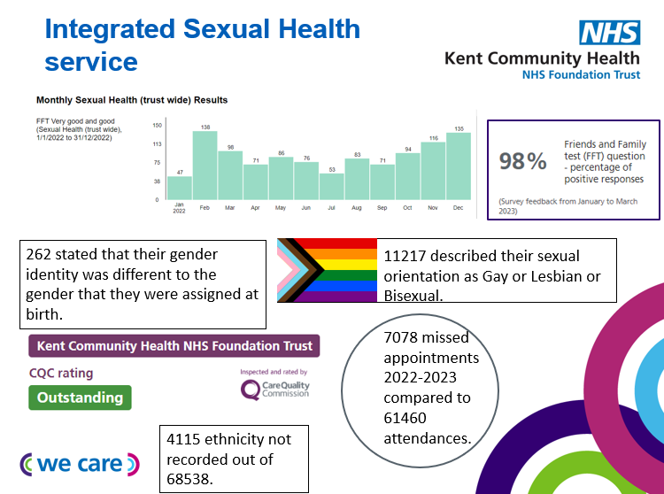  In conclusion, there are multiple ways to access the service. The service are seeing a wide range of patients as shown by their data sets across different characteristics including ethnicity, sexual orientation and gender identity. Although, the service for 2022/2023 had an 11.5% missed appointment rate so this could be an indicator of access issues.  Staff highlighted some areas such as Sheppey where public transport services are more limited and other areas where physical sites were closed. The Roma community were also mentioned as experiencing poorer access to the service. Service leads are keen to look into ways to address any issues. Some technical issues were also mentioned by patients for the telephone system. The service is already working to resolve this issue.  There had been some significant changes to how the service is delivered and many staff commented that the service had become even more accessible since the start of the pandemic. The live chat option was cited by staff and patients as increasing access.  One You smokefree  - During face to face with client, client reported being unable to access any of the nicotine replacement therapy products in any of the pharmacies near where she lives.  - Some issues with waiting times to be seen. One client waited 3 months for the Targeted Lung Health Check appointment.  - Feedback received from clients that the service is convenient and local.  - Staff report that access to the service has increased since being able to offer telephone support and pharmacy home delivery is available for nicotine replacement products.  - If someone wants a face to face appointment they will often be seen quicker.  - One staff member reported difficulties with carrying out targeted work when there is a wait list to work through.  - The service are looking into British Sign Language training for staff.  - Feedback from staff that they have never struggled to get someone the help that they need. It is a blended offer with our other One You services.  One You smokefree datasets  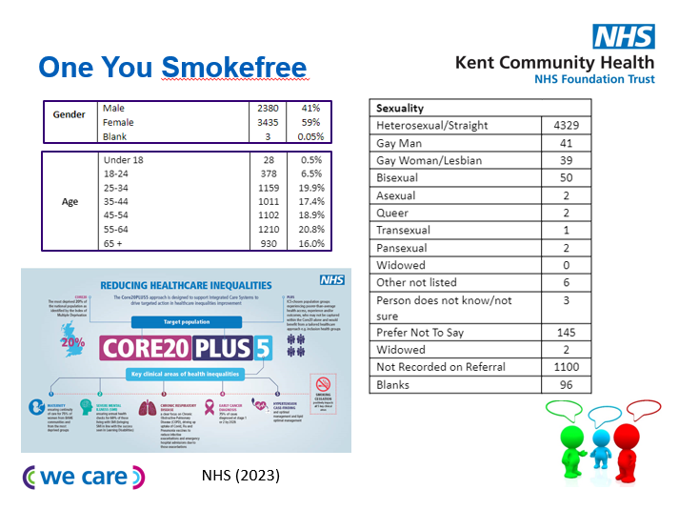  When comparing One You smokefree service data with local data around smoking rates, there were marked differences in expected breakdown of clients seen when compared to clients actually seen particularly around the characteristics of age, sexuality and gender. Therefore, data could indicate that access in some areas is an issue.  One client was struggling with the availability of products as not all pharmacies are signed up to the programme. The service is already working to get new pharmacies on board to ensure there is good coverage across districts. Some clients also commented that they had not heard of the service before and were only accessing it following targeted work to reach them. There were concerns raised by staff around advertising and service capacity. The service is already looking into marketing and recruitment to increase access as clients are not automatically referred in. Some staff commented that being able to offer telephone support and pharmacy home delivery has increased access to stop smoking support. The Targeted Lung Health Check offer has also meant that the service is reaching people who had not previously used the service before. Training around sensory needs for staff could also increase access for clients with additional communication needs.  Trust wide service feedback  - Feedback from the People’s Network that patients and service users are not always asked about accessibility needed when appointments are booked. | 2+3+2  Average score: 2 | Senior Clinical Lead for Cardiac Rehabilitation Service.  Head of Service: Integrated Sexual Health, TB Nursing and Rough Sleeper Nursing Service.  NHS Health Checks and Specialist Smokefree Service Programme Manager and Specialist Service Team Manager-Smoke Free.
 | 1B: Individual patients (service users) health needs are met | Cardiac Rehabilitation service  - Several patients report that they feel their health needs are being met and that they have the support that they need.  - Positive feedback received about the educational workshops.  - Some patients report that their confidence has grown through receiving support from the service.  - Feedback from staff that they feel as a service they meet a lot of extra needs, but it is hard when patient needs fall outside of the service remit.  - Positive feedback received about the counselling service.  Observations showed that information about reasonable adjustments, PALs and staff information were clearly displayed and that plans of care were individualised. The service could also meet a range of needs and patients were offered a “menu-based approach”. There was evidence of good communication between staff across clinic and exercise rehabilitation around tailored support for patients. The counselling service and educational workshops were also considered excellent for providing wrap around support to patients.  Interpreting services were raised as the main concern by staff. This had been escalated to the Health Inequalities team who support services to access interpreting and translation. They also mentioned about when needs are outside of their remit and difficulties with referrals. The service are working closely with other services within the Trust to help resolve any issues with referrals being picked up.  Integrated Sexual Health service  - The majority of patients reported that they felt that their needs are met.  - Some issues with booking appointments.  - Being offered a regular team of Nurses and a Consultant considered helpful for establishing trust.  - The Roma community mentioned as being unaware of how to access the service. The Outreach service helps to partially meet needs but only if facilitated.  - Staff felt that as a service they go above and beyond their remit and that people aren’t turned away but put in touch with someone.  - More outreach mentioned by staff.  In conclusion the service is able to meet a wide range of needs. The Sexual health live chat team were regularly signposting service users even if they could not meet the needs themselves. The Sexual health live chat option has also proved a popular pathway for the d/Deaf community. There was an indication that ROMA communities using the service were experiencing issues with access due to a lack of interpreters and communications not being translated. The service are keen to resolve this issue and work with the Outreach Team to understand more about any steps that could be taken to address this.  One You smokefree  - Client feedback received that the service is very adaptable.  - All of the clients felt that their needs were being met or would be met once they quit smoking.  - The advice and the explanations around the different nicotine replacement products was popular with clients.  - Comment from client that being able to offer aids to quit for free makes the service more accessible.  - Comment received from a staff member that they have a good robust procedure & policies in place. They can always access training if there is an area they are unsure about and there are weekly team meetings to problem solve or for peer support around complex cases.  - There is a high quit rate for clients accessing the service.  - One staff member commented that they don’t do many referrals or signposting.  - One staff member reported how they were able to enhance their support to meet health needs by having the opportunity to shadow Nurses as part of the Targeted Lung Health programme and learn about how to answer queries from clients following scans.  In conclusion, the service observations showed that every client had tailored advice around products, cravings and motivation to reflect different needs and lifestyles. Many clients reported how flexible and adaptable the programme was which also helped clients especially when they were struggling with products or motivation. The products being available for free was also seen as a positive by clients which helped the programme to be more accessible.  Support for staff was highlighted as a real positive as they could access support with any issues which would then help clients. Referrals and signposting were mentioned as not being that frequent for some staff. Service leads are already supporting staff around this so they are aware of onward support or support around specific health needs outside of the remit of the One You smokefree service.  Trust wide service feedback  Feedback from the Healthy Communities Steering Group that there could be more signposting and that smaller charities often have poorer knowledge of services as well as not receiving much regular information from the Trust.  Feedback from the West Kent Health and Care VCS Alliance that Kent Community Health NHS Foundation Trust could do more to bridge the gap with the Voluntary, Community and Social Enterprise sector. | 3+3+2  Average score: 2 | Senior Clinical Lead for Cardiac Rehabilitation Service.  Head of Service: Integrated Sexual Health, TB Nursing and Rough Sleeper Nursing Service.  NHS Health Checks and Specialist Smokefree Service Programme Manager and Specialist Service Team Manager-Smoke Free.
 | 1C: When patients (service users) use the service, they are free from harm | No reported incidents from One You smokefree or Integrated Sexual Health Service. One concern raised for Cardiac Rehabilitation service by a patient who requested a call back for a pressing health concern, but did not receive one. There is procedure in place it was just not followed on this occasion.  In conclusion there were no concerns raised regarding risk of harm from using any of the services. There was one concern raised where a patient did not receive a call back but as this was caused by a procedure not being followed on that occasion the likelihood of reoccurrence of the issue is low. The concern also did not affect the patient’s confidence in using the service. | 2+3+3  Average score: 3 | Senior Clinical Lead for Cardiac Rehabilitation Service.  Head of Service: Integrated Sexual Health, TB Nursing and Rough Sleeper Nursing Service.  NHS Health Checks and Specialist Smokefree Service Programme Manager and Specialist Service Team Manager-Smoke Free.
 | 1D: Patients (service users) report positive experiences of the service | Cardiac Rehabilitation service  - Feedback from several patients that the service is excellent and many don’t want to leave.  - Several patients said that they had a very positive experience with reassurance and being able to ask questions highlighted as real positives.  - Good information sharing amongst professionals was highlighted by some patients.  - Several patients felt that it was wrap around support and the  - Feedback from staff that they rarely receive feedback that isn’t positive.  - All staff felt that patients have a good experience of the service and that they often hear from patients that they don’t want to leave.  - One staff member felt that as a service, complaints are dealt with well and they are usually not to do with the service.  - The biggest issue by one member of staff was felt to be communication with London Hospitals as patients can become confused about why they have been referred or there are often delays in referrals so patients miss out on support they could have had.  - One of the service volunteers commented that they have seen people go from not being invested to suddenly really interested after receiving support from the service.  - Observation that patient surveys are usually given to the patient in paper format and then handed back to the Nurse so that they can be manually uploaded.  For the Cardiac Rehabilitation service patient experience was extremely positive with several patients commenting that they didn’t want to leave the service. The main issues raised by patients were not always being clear about their support being individualised so not receiving the same support as other patients and lack of co-ordination from other health professionals and the service. The service had already taken steps to improve co-ordination with Hospitals and GPs in particular by passing across information about their service and referral pathways.  Integrated Sexual Health service  - 98% of the Friends and Family Test question scores are positive.  - There are multiple positive patient responses on Google listings.  - HIV support singled out as fantastic both in clinic and through peer support service.  - 18 of the 20 patients who were part of the engagement phase reported a positive experience overall.  - Staff report that the service is more open and accessible and waiting times have reduced since the start of the covid pandemic.  - The Healthy Communities Steering Group stated that there is a lack of understanding around people being triaged.  - The SMS and webchat options are amazing for deaf people and also work well for young people.  - Feedback from the VCSE sector that there are barriers for the Roma community with appointments particularly around having to input details online and showing up to an appointment without an interpreter.  For the Integrated Sexual Health service evidence showed that patient experience was predominantly positive and it was mainly due to technical issues when patient experience was not as positive. The service also had a 98% positive score for the Friends and Family test question and many responses had been recorded. The service experience of HIV patients was especially positive through being offered the same team of Nurses and Doctors and being able to contact clinical teams directly about concerns, appointments and medication. Digital offers were also mentioned as being really positive for young people and for the d/Deaf community.  However, the Roma community were mentioned as having a difficult experience with the service due to the need to input details online and lack of availability of interpreters. Service leads are looking into this.  One You smokefree  - One client reported that they were really happy as their Adviser was open and they felt relaxed.  - Two clients commented that they were impressed, really happy and couldn’t think of any improvements. They also highlighted the importance of not feeling judged.  - Feedback received from a client that they had tried five times to quit before and that this was the only time it has worked citing the support as making the difference.  - Comment from a client that the Adviser was very welcoming and friendly and they were given a lot of reassurance and enjoy coming.  - One client stated that the service was excellent, they hadn’t had to wait too long for any of the support and that they would recommend the service to others.  - Staff did comment that all experience surveys are completed with the client and they wonder if the answers would be different if they weren’t.  - A volunteer for the Trust commented that they had used the service and it was excellent so they would recommend it to others.  One You smokefree health outcome data  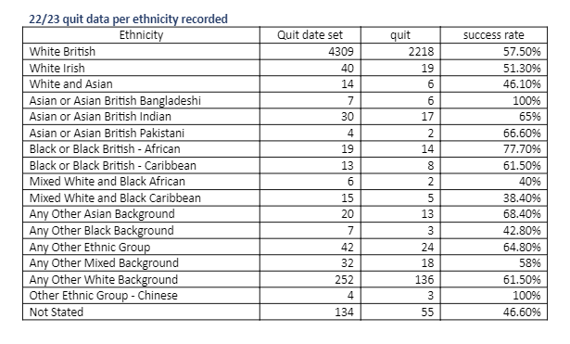  In conclusion for One You smokefree service client experience was overwhelmingly positive. Several clients commented that they felt at ease with Advisers and did not feel judged. Although waiting lists were mentioned by clients, staff within the service were transparent about this with clients offering alternative ways to access the service and action had already been taken by the service to increase capacity in areas where this had been highlighted as an issue such as within the Targeted Lung Health Check programme.  Health outcome data also indicates that service experience is good across at least one protected characteristic. For ethnicity, success rates were actually higher than the national average quit rate for NHS stop smoking services for all but 5 of the different ethnic groups. | 3+3+3  Average score: 3 | Senior Clinical Lead for Cardiac Rehabilitation Service.  Head of Service: Integrated Sexual Health, TB Nursing and Rough Sleeper Nursing Service.  NHS Health Checks and Specialist Smokefree Service Programme Manager and Specialist Service Team Manager-Smoke Free.
Domain 1: Commissioned or provided services overall rating |  |  | 10

Domain 2: Workforce health and well-being
Domain | Outcome | Evidence | Rating | Owner (Dept/Lead)
Domain 2:  Workforce health and well-being | 2A: When at work, staff are provided with support to manage obesity, diabetes, asthma, COPD and mental health conditions
 | 2B: When at work, staff are free from abuse, harassment, bullying and physical violence from any source
 | 2C: Staff have access to independent support and advice when suffering from stress, abuse, bullying harassment and physical violence from any source
 | 2D: Staff recommend the organisation as a place to work and receive treatment
Domain 2: Workforce health and well-being overall rating

Domain 3: Inclusive leadership
Domain | Outcome | Evidence | Rating | Owner (Dept/Lead)
Domain 3:  Inclusive leadership | 3A: Board members, system leaders (Band 9 and VSM) and those with line management responsibilities routinely demonstrate their understanding of, and commitment to, equality and health inequalities
 | 3B: Board/Committee papers (including minutes) identify equality and health inequalities related impacts and risks and how they will be mitigated and managed
 | 3C: Board members and system leaders (Band 9 and VSM) ensure levers are in place to manage performance and monitor progress with staff and patients
Domain 3: Inclusive leadership overall rating
Third-party involvement in Domain 3 rating and review
Trade Union Rep(s): | Independent Evaluator(s)/Peer Reviewer(s):

EDS Organisation Rating (overall rating):

Organisation name(s):

Those who score under 8, adding all outcome scores in all domains, are rated Undeveloped

Those who score between 8 and 21, adding all outcome scores in all domains, are rated Developing

Those who score between 22 and 32, adding all outcome scores in all domains, are rated Achieving

Those who score 33, adding all outcome scores in all domains, are rated Excelling

EDS Action Plan
EDS Lead | Year(s) active
Health Inequalities Team | 2023-2024
EDS Sponsor | Authorisation date

Domain | Outcome | Objective | Action | Completion date
Domain 1: Commissioned or provided services | 1A: Patients (service users) have required levels of access to the service | Cardiac Rehabilitation Service  For venues used for exercise referral programmes to be fully accessible with good transport links.  Integrated Sexual Health service  To explore barriers experienced by local Roma populations in accessing the service.  For patients to be able to use the telephone system without being disconnected and being able to get through to the service department that they require.  One You smokefree  To reduce waiting lists for the Targeted Lung Health Check service so that readiness to quit is not affected.  To explore different opportunities for marketing the service which have not been used before.  To offer all clients information about parking and directions when face to face appointments booked.  To explore the option of an online pharmacy as a result of patient feedback about issues with getting nicotine replacement therapy through pharmacy. | Cardiac Rehabilitation Service  To seek support from the Public Health Events Officer around venues for exercise programmes.  Integrated Sexual Health service  To speak to members of the Healthy Communities Steering Group about more information about the barriers that Roma populations are experiencing and relay to the Integrated Sexual Health Service.  To explore the issues around the telephone system.  One You smokefree  This is an Integrated Care Board and Company Chemists’ Association project, but there are plans to expand into Medway and swale in early/mid 2024 and across all localities in Kent in the next 2 years.  A marketing swap to stop initiative is being developed in targeted coastal towns and with LGBTQ community/ drug and alcohol users.  To ensure all clients have information about parking and directions when face to face appointments booked.  To find out more information about the issues with getting nicotine replacement therapy through pharmacy. | 24.11.2024  Ongoing.  To be confirmed.  March 2026  17.11.2024  17.11.2024  March 2024
 | 1B: Individual patients (service users) health needs are met | Cardiac Rehabilitation Service  To identify any trends about inappropriate referrals.  Integrated Sexual Health Service  For members of the HIV peer support group to be aware that smear tests as part of their HIV treatment plan can be provided by the Sexual Health service.  To reduce the number of inappropriate referrals received.  For equality monitoring questions to be embedded into all standard operating processes.  For all staff in the service to attend an Equality Monitoring workshop.  One You smokefree  To create a process for better utilisation of cancelled/missed/ not booked face to face meeting appointment slots.  One You smokefree  To increase referrals to Voluntary Charity Social Enterprise and community partners to support wider health needs. | Cardiac Rehabilitation Service  To gather further information about inappropriate referrals.  Integrated Sexual Health Service  To inform the HIV peer support group about the availability of smear tests from the service.  To work with Primary Care Networks around inappropriate referrals.  Already in place in most parts of the service, so it could just be extended to other parts of the service such as Live Chat.  Dates have been booked already so no further action required unless any staff are unable to make the workshops.  One You smokefree  To find out the reasons behind why clients are cancelling, missing or not booking face to face appointments to help identify any trends.  One You smokefree  To provide education/support to Advisers. | 24.11.2024  Completed.  Ongoing.  November 2024  March 2024  24.11.2024  31.01.2024
 | 1C: When patients (service users) use the service, they are free from harm | Cardiac Rehabilitation Service  For all patients with immediate health concerns to receive a call back. | Cardiac Rehabilitation Service  To ensure that all staff are using the Buddy System correctly and provide further training and support as and when required. | 24.11.2024
 | 1D: Patients (service users) report positive experiences of the service | Cardiac Rehabilitation Service  For FFT (friends and family test) scores to reflect the timeframe in which they refer to and to be able to identify trends with the information.  One You smokefree  For clients to have choice over how they wish to complete survey at the end of their programme.  To understand more about the service experience for clients using third party providers for full interventions to identify any areas for development. | Cardiac Rehabilitation Service  To review the process for survey completion and uploading the information.  One You smokefree  Started. Clients were sent out the surveys by text but completion rates were low, most clients happy to complete with Adviser. To remind clients about choice for future programmes.  To carry out patient experience research of those clients using third party provider for full interventions. | 24.11.2024  17.11.2024  June 2024

Domain | Outcome | Objective | Action | Completion date
Domain 2:  Workforce health and well-being | 2A: When at work, staff are provided with support to manage obesity, diabetes, asthma, COPD and mental health conditions
 | 2B: When at work, staff are free from abuse, harassment, bullying and physical violence from any source
 | 2C: Staff have access to independent support and advice when suffering from stress, abuse, bullying harassment and physical violence from any source
 | 2D: Staff recommend the organisation as a place to work and receive treatment

Domain | Outcome | Objective | Action | Completion date
Domain 3:  Inclusive leadership | 3A: Board members, system leaders (Band 9 and VSM) and those with line management responsibilities routinely demonstrate their understanding of, and commitment to, equality and health inequalities
 | 3B: Board/Committee papers (including minutes) identify equality and health inequalities related impacts and risks and how they will be mitigated and managed
 | 3C: Board members and system leaders (Band 9 and VSM) ensure levers are in place to manage performance and monitor progress with staff and patients

Patient Equality Team
NHS England and NHS Improvement
england.eandhi@nhs.net

