  - Equality Delivery System 2022
Case Study

Domain 1: Commissioned or provided services
Organisation Details
Name of organisation(s) |  | Kent Community Health NHS Foundation Trust
Type of organisation(s) |  | NHS community service provider
Senior Responsible Officer (SRO)
SRO organisation and contact details
SRO contact details
Name of Organisation | Last EDS2 publication date |  | Name of Organisation | Last EDS2 publication date
Kent Community Health NHS Foundation Trust | October 2021
Name of Organisation | Last EDS2 publication date |  | Name of Organisation | Last EDS2 publication date
Responsible Officer(s) – please list one for each NHS organisation |  | Health Inequalities Team, Kent Community Health NHS Foundation Trust (Domain 1)

Version 1, 15 August 2022

Domain 1: Commissioned or provided services – Engagement
Executive summary  Lessons learnt | The Equality Delivery System (2022) is a system which helps NHS organisations to improve the services they provide for their local communities, provide better working environments free from discrimination for NHS employees while meeting the requirements of the Equality Act (2010) (NHS England, 2023). The Equality Delivery System (2022) is split into eleven outcomes against which NHS organisations measure their successes and challenges with protected characteristic and vulnerable community groups using evidence and insight across three Domains which are: Domain 1: Commissioned or provided services, Domain 2: Workforce health and well-being and Domain 3: Inclusive leadership.  This case study is in reference to work completed for Domain 1. For Domain 1 services are required to choose three services for assessment. Service number 1 should be a service where data indicates it is doing well, service number 2 where data indicates a service is not doing so well and service number 3 should be a service where their performance is unknown. For each service, the following four outcomes should be tested alongside local data and insights and in discussion with service users, patients, the public, community groups and Voluntary, Community and Social Enterprise (VCSE) organisations in order to provide intelligence on the lived experience of partners and stakeholders to identify and implement initiatives that bring about positive change:  1A: Patients (service users) have required levels of access to the service.  1B: Individual patients (service user’s) health needs are met.  1C: When patients (service users) use the service, they are free from harm.  1D: Patients (service users) report positive experiences of the service.  Below is a summary of the stages in our process for completing work around Domain 1 of the Equality Delivery System (2022) with lessons learnt to take forward to future applications.  Stage 1: Insight gathering  - Meetings with Health and Wellbeing Lead (responsible for Domain 2) and Head of Workforce Equity, Diversity and Inclusion to discuss expectations around the Equality Delivery System (2022). Action log and webchat set up to be in place for the duration of the work on all three Domains.  - Situation, Background, Assessment and Recommendation form created with Health and Wellbeing Lead and sent to Executive Team and Integrated Care Board with a project proposal document for work around Domain 1 to inform them of our intentions to carry out engagement work.  - Gantt chart created for expected timescales for work around Domain 1. This was shared with Domain 2 and 3 leads.  Stage 2: Service selection for Domain 1  - Analysis of Power BI reports, CQC reports, HEAs, local Joint Strategic Needs Assessments, the Friends and Family Test question scores, health outcome data and service’s own service data in order to identify which three services we were going to choose for the Equality Delivery System (2022). Multiple data sets used in case of anomalies. Supplemented with soft intelligence from the service when less data sets available.  Stage 3: Planning engagement  - Initial meetings with service leads to explain service choice and aims and objectives around the Equality Delivery System (2022).  - Insight gathering with service leads to understand more about the context of their services and to establish opportunities for engagement with staff, patients and clients.  - Meeting with Health Inequalities Team to identify additional VCSE stakeholders.  - Briefing documents sent out to service staff about the planned engagement.  - Staff and VCSE representatives approached about requests to attend meetings and clinics.  - Questions formulated for Domains 1 and 2 with Health and Wellbeing Lead and sets of surveys created (Domain 2 questions only for use with staff engagement). Multiple methods chosen for engagement to give a “true” picture of each service and gain insight into lived experience of staff, clients and patients.  Stage 4: Engagement phase  - Creation of an engagement log to record engagement activity and other evidence. Additions made to the log in response to emerging evidence during the engagement phase.  - Feedback gathered from staff, patients, clients, volunteers and VCSE representatives around the four outcomes for Domain 1 through online surveys, 1 to 1s, meetings and groups alongside evidence from observations, online reviews, e-mail feedback and soft intelligence. Staff asked Domain 2 questions at the same time to join up the Domains.  Stage 5: Collation of evidence  - Evidence analysed from engagement log alongside initial data which informed service selection for Domain 1 to determine any emerging themes, what was working well and any areas for development.  - Individual service reports created with considerations and action plan.  - Creation of a case study with a write up of the work completed for Domain 1 and lessons learnt.  Stage 6: Feedback to services  - Raw data from the engagement logs sent to service leads.  - Individual service reports presented to service leads and scoring for Domain 1 completed with services.  - Amendments, additions and extra information added to action plans following meeting with service leads (progress had already been made around some of the actions).  Stage 7: Sign off  - Individual service reports, case study and main report shared with Population Health Group and Public Health Governance board for sign off ahead of publication.  - Final amendments made to reports and case study.  Stage 8: Publication and review  - Publication of case study and main report to Kent Community Health NHS Foundation Trust public website (individual service reports available on request and detailed in main report).  - Six-month reviews of action plans following completion of work around Domain 1. Dates booked for reviews with services.  - Published report and individual service reports shared with stakeholders.  For future applications of the Equality Delivery System (2022) we would:  - Factor into our planning initial conversations with the VCSE Alliance and the creation of some task and finish groups inviting members from the local VCSE alliances to join for specific services rather than asking the questions more generally at the quarterly meetings.  - Consider geography as a key consideration when planning engagement opportunities. Rather than just asking all staff if anyone would be happy for us to attend a clinic or group we could reach out to staff in areas where there are known gaps as well as areas where there is good or poor service uptake in order to have a wider picture about access and service experience.  - Explore the option of completing calls to patients or service users for areas where there are higher rates of did not attends or was not brought recorded.  - Explore further ways to engage with staff around the outcome areas for Domain 2.  - Utilise the QR code option more for future online surveys especially with patients and clients. We could create some posters which could be placed in patient and client waiting areas for the duration of the engagement phase.  - Explore telephone survey completions. We didn’t use this option as we had an abundance of evidence obtained through the engagement phase. However, this could be helpful if we were to target patients or clients from protected characteristic cohorts who access the services via telephone only. This would help us to better understand any barriers to being seen in person.  - Explore ways to engage with more Carers. Although we did engage with some Carers in group settings as part of working with our VCSE representatives this was more by chance rather than this being planned. We did not engage with any Carers on a 1 to 1 basis. We have a trust owned Carer survey within the Trust which undergoes regular amendments to suit needs. It could be possible to add some additional questions to that alongside considering other ways of reaching out.  - Consider inviting a patient, client or VCSE representative to help with scoring services against the four outcomes for Domain 1.  - Ask services about their data collection processes in order to help acquire the best quality data to determine evidence base for possible selection.  - Consider a wide range of evidence alongside data especially if data systems have recently changed to better understand performance and inform decisions around service selection. This could include more local census data for example.  - Consider including responses to equality monitoring questions in the engagement log to ascertain during the engagement phase if there are any gaps in responses from particular geographical areas or if there are additional groups we would like to engage with.  - Consider asking services in initial meetings ahead of the engagement phase about any action plans that currently exist around any other pieces of work such as the HEAs to determine if they are already aware of any gaps and any pre-escalated issues. This would help at the action plan formulation stage to know which actions are already taking place to avoid duplication.
Full Report  Please explain how you engaged with your patients and services users, their carers and representatives?  Was this different to previous engagement? | The first step for planning engagement was to have a number of preliminary meetings with our Health and Wellbeing Lead responsible for overseeing evidence collation for Domain 2 and our Head of Workforce, Equity, Diversity and Inclusion responsible for evidence collation for Domain 3. These meetings helped to establish the expectations around the Equality Delivery System (2022) and to discuss ideas for how we can engage with patients, service users, their carers and representatives recognising them as key stakeholders. A Situation, Background, Assessment and Recommendation document was created in partnership with our Health and Wellbeing Lead alongside a project proposal document for Domain 1, both of which were submitted to our Executive Team and Integrated Care Board to inform them of our intentions to carry out engagement and to invite any input. An action log and webchat were then created with Domain leads to keep everyone informed about how work was progressing and to work collaboratively to design engagement tools.  Figure 1: Project proposal for Domain 1  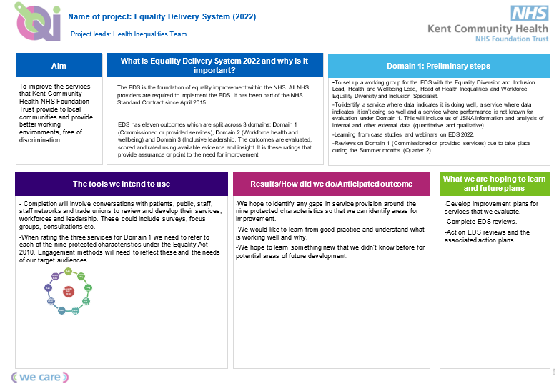  For Domain 1 we used a multi method approach to engagement in order to triangulate evidence and get a “true picture” of patient and client experience of our services. Before the engagement began we met with service leads to explain why we had chosen their service for Domain 1 using data and soft intelligence. We spoke about our overarching aim as a result of completing the Equality Delivery System (2022) work, the steps in the process which included tools for acquiring evidence for Domain 1, the anticipated outcome and future plans (see figure 1 above). We then asked service leads more about the context of their service which included strengths, weaknesses, opportunities and threats and where possible additional information about any political, economical, social, technological, legal or environmental influences (see figures 1a, 1b and 1c).  Figure 1a Cardiac Rehabilitation service  Strengths Weaknesses  - Health equity audit completed (see page 14 for definition) has been completed and presented to the service. - Staff know their cohort really well and the types of patients that will most likely engage. - As a service a lot of work has been done to try and reach as many people as possible such as using different venues, days and times for meeting etc. - Staffing is an issue at present. - Travel or not being interested in the service are common reasons patients don’t attend their appointments. - The figures for the health equity audit weren’t quite right and ringing true, although it doesn’t really alter the overall findings.  Opportunities Threats  - The exercise referral programme is a good way to engage with people as they are usually accessing all aspects of the Cardiac Rehabilitation Service. - Telephone calls are most likely the best way to reach patients. - There are two whole service meetings each month. These will be the best ways of reaching staff. Faye can arrange for attendance. - Support is mainly delivered online, via telephone or in patient’s homes. - The service is supporting a lot of patients who work 0 hour contracts and so they would need to take annual leave to attend health appointments. - There is spare funding for the service. A bus has been suggested a few times but been turned down (Public Health Bus information shared). - The service is unsure what more that they can do to be as accessible as possible.  Figure 1b Integrated Sexual Health service  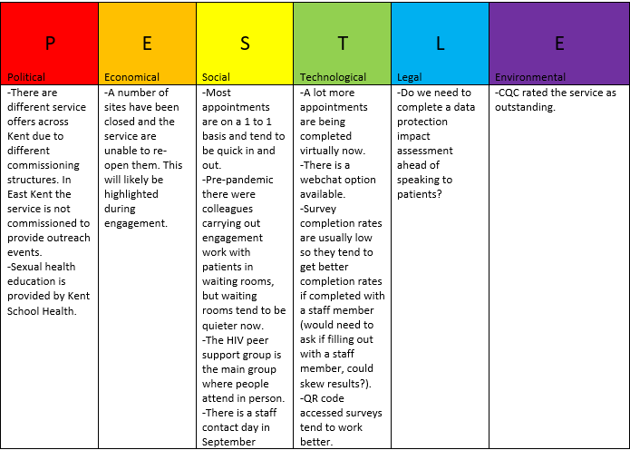  Figure 1c One You smokefree  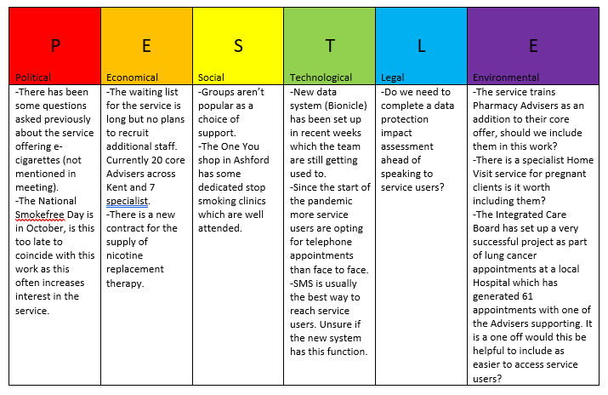  The initial insights gathered from meeting with service leads helped to inform which methods of engagement would work best for each service as well as helping us to work out how engagement could be factored into day to day service delivery rather than being a time intensive add on in order to reduce service disruption.  We created a set of surveys (see appendix) with questions to match the outcomes being scored for Domain 1 which could be completed by staff, patients, clients, volunteers or community partners either anonymously online, in 1 to 1s or in a group setting. By keeping the questions consistent across all different methods of engagement this facilitated fairer comparisons and analysis of evidence generated. Some equality monitoring questions were included in order to ensure that we engaged with a wide range of staff, patients and clients although no personally identifiable information was collected in order to protect confidentiality and to ensure that online surveys could be completed anonymously to encourage open and honest feedback. The questions were designed following the national format used within the NHS Patient Experience Surveys because patients and clients would be used to being asked them in this way (NHS England, 2023). We also created some questions for Domain 2 which were included in the online and in person staff surveys.  When conducting interviews or group discussions using the survey questions we created some information sheets about the Equality Delivery System (2022) work for Domain 1 (see appendix) which were given out. Question 1C in relation to outcome 1C (When patients (service users) use the service they are free from harm) was omitted for group discussions to maintain patient and client safety around any disclosures.  For online surveys we used the SurveyMonkey software: SurveyMonkey - Free online survey software and questionnaire tool to create the set of surveys as we had the licence within the trust at the time and the software had the functionality that we required. We created QR codes and also included details about our Patient Advice and Liaison Service (PALS) so that anyone choosing this option would still have the opportunity to pass on any compliments, complaints or queries around any of their comments.  Prior to commencing the engagement, a briefing document was sent out to all staff across all three services to inform them of the planned engagement, give them the weblink for the anonymous staff survey and to invite them to a lunchtime session where they could ask any questions in person or virtually. They were also able to contact us directly regarding any queries. We also created a briefing document for our VCSE partners which was sent to them ahead of engagement. They were also invited to contact us regarding any queries.  During the engagement phase we attended team meetings, a staff away day with our Health and Wellbeing Lead, carried out 1 to 1 interviews with staff, patients or clients and volunteers and for one service with staff from another NHS Trust who were working in partnership with them. We received a number of completed patient online surveys and one VCSE completion. The evidence was then put together with evidence collected from additional sources (we will discuss this in more detail later).  This approach was different to previous engagement as this was a “deeper dive” into services and patient or client experience. All engagement methods were offered to all three services although some methods worked better than others based on the service needs and how their patients or clients are seen or interact with their service. For instance, online surveys worked well for the Integrated Sexual Health service. Their service delivery methods changed since the Covid pandemic so they now have virtual appointments and webchat options available. Therefore, patients are used to interacting with the service online. In contrast for the Cardiac Rehabilitation service their patients are usually seen face to face and in a group setting so there were a lot of opportunities to engage with patients this way. For us it showed the importance of having multiple methods of engagement available in order to be able to flex methods to services and not miss out on engagement opportunities.
When did you start engagement with your patients and services users, their carers and representatives?  Was this different to previous engagement? | Engagement with service staff really started back in June 2023 when we met with them to discuss our intentions to work with their service on the Equality Delivery System (2022). We wanted to work in partnership with services and be respectful of the context in which our work would be taking place. The initial conversations gave insights into the best ways to engage with staff, patients and clients and provided initial evidence about how they felt their services were performing in relation to the outcomes for Domain 1. Our original aim was to carry out engagement with service staff, patients, service users, carers and representatives during the summer months as suggested in the Equality Delivery System (2022) guidance document, but all three services felt that it was not a good time to try and engage with staff due to high levels of annual leave during this time. The engagement ran from September to November instead (see figures 2a and 2b) as there were some key meetings and opportunities that we wanted to make sure were included such as staff away days, whole team meetings and programme sessions.  Figure 2a  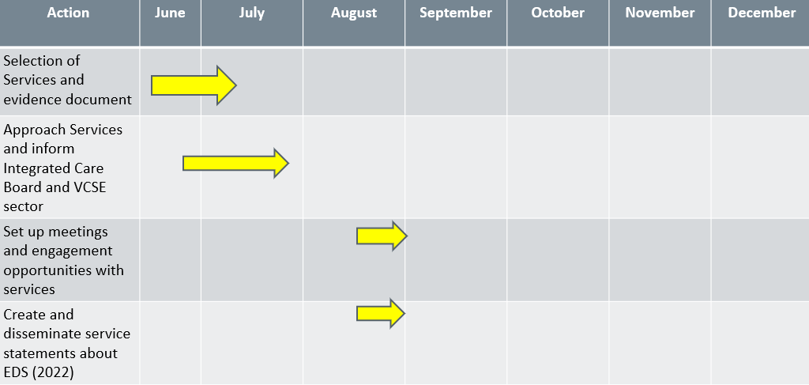  Figure 2b  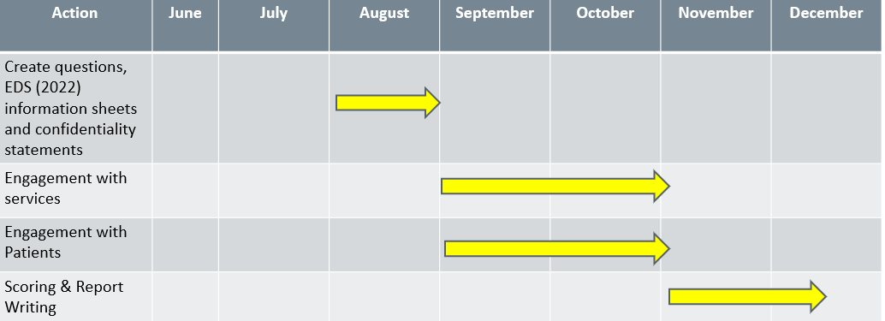  The engagement was different than what had taken place before as the stakeholder cohort was much wider and involved more external representatives, reflecting the system wide work taking place in the local communities that we serve. There was also a considerable amount of flexibility and adaptability factored into the planning stages and engagement phase. If we relate this to a project management methodology we adopted a more agile or evolving approach to the work for Domain 1. Due to the outcomes for Domain 1 being focused on patient/client access and experience our approach needed to be less rigid so that we did not shut ourselves off to opportunities to hear from different stakeholders (for instance extending the engagement phase so that we could include key meetings) and so we could be open to evidence sources that perhaps we had not planned for and we were not aware of at the beginning such as google listings or e-mail feedback.
Who was part of your engagement?  How did you decide who to engage with? | For the engagement phase for Domain 1, the question as to who was part of the engagement was slightly different for each service. The decisions around who to engage with were based on initial meetings held with services and also using the knowledge from work carried out by the Health Inequalities Team previously. The People’s Network and Healthy Communities Steering Group are two groups that are led by Kent Community Health NHS Foundation Trust but membership is made up of former staff, governors, patients, carers and VCSE representatives so they were recognised for the valuable insights they could offer around Domain 1. The Health Inequalities Team had also worked closely with the VCSE Alliances and so they were also suggested as key stakeholders for this piece. However, some stakeholders were identified as the engagement phase was underway.  For the Cardiac Rehabilitation service, we knew that we wanted to engage with patients attending clinic and patients attending the exercise rehabilitation programme as these were the most popular pathways for patients. However, whilst attending the exercise rehabilitation session a Volunteer was identified. The volunteer was not someone who we had planned to engage with in the beginning but they had been a volunteer for a number of years and had been through the service so were able to provide a lot of insights.  For the Integrated Sexual Health service, we were able to get a lot of information from the initial meeting with service leads so had a good understanding around who we wanted to engage with. We were particularly keen to engage with patients who had used the Sexual Health Live Chat service as this was the newest support offer from the service and was specifically designed with the aim of increasing service access and improving patient experience. The HIV peer support groups was also one of the only groups where people attend in person (virtually). We were also very fortunate that the whole service away day was taking place and so we wanted to speak to staff on a 1 to 1 basis especially as they were working across Kent. However, many of the stakeholders we engaged with became apparent as the engagement phase progressed. Following attendance at the away day we were subsequently invited to two of the weekly team meetings for different arms of the service. These meetings yielded new insights and brought up new topics which were specific to their particular part of the service.  For One You smokefree we were also given a lot of information in the initial meeting with the service leads. We knew we wanted to engage with clients from the Targeted Lung Health Check programme and from the One You shop (high street based) as both were innovative in their approach and were aimed at improving access to stop smoking support. However, whilst attending both clinics in person it became clear that the services were operating as part of a much wider health promotion offer. The One You shop clinic operates alongside other health services and so staff who oversee the shop and refer into the service regularly were able to provide valuable insights particularly around access. The Targeted Lung Health stop smoking clinic also takes place as part of a larger pathway of support and so we identified an opportunity to engage with staff from another Trust working at a different stage of the client journey.
Please describe any issues or barriers you experienced during the delivery of your engagement | One of the main issues we encountered was when we took our questions to a VCSE Alliance meeting to feedback at a Trust wide level or individual service level. The reason we chose to ask the questions this way was because there was a large attendance at the meetings with membership from a number of different community partners. It was mentioned that it was difficult for members to give feedback generally as many of the services that the members represented had only had experience with one or two of our services.  In addition to the meetings attended, communications were sent out by the VCSE Alliance Leads with a link to a VCSE survey which did allow anyone completing it to complete it at a Trust wide or service level. Although, a large number of people were reached this didn’t result in anyone making contact or completing the VCSE survey that we created. However, this approach did work for the Healthy Communities Steering Group and feedback was received about a service which brought new insights. Therefore, some conversations with the groups representing the VCSE sector prior to engagement similar to those that took place with service leads this time round could be helpful in future to gain a sense as to the best methods for seeking meaningful engagement. It was suggested that perhaps for future engagement work we could approach the VCSE Alliance with information about which services we are seeking feedback for so that some smaller focus groups of stakeholders specific to those services could be put together. This could help to improve the quality of the feedback received.  We also encountered some problems with having the correct in person patient and client meeting opportunities. We were reliant on staff from within the services inviting us to come and spend a morning, afternoon or day with them. For the Cardiac Rehabilitation service, it was helpful to be able to attend a clinic and an exercise programme as it provided different insights and engagement opportunities and showed how the two different parts of the service fit together. For One You smokefree we were able to attend a stop smoking clinic at the One You shop and a clinic as part of the Targeted Lung Health Check programme both of which are innovative approaches for meeting client need. They also provided opportunities to meet with representatives from other services at the physical sites in order to understand the partnership working. However, for both services it would have been helpful to have been able to go to clinics and programmes in other areas across Kent. For the Cardiac Rehabilitation service, the clinic and programme, although at different sites, were both in the same locality and whilst they did provide evidence of a good level of access and positive patient experience, it would have been helpful to have been able to compare the service access and experience with patients in Thanet where there is not an exercise programme in place. Similarly, for One You smokefree it would have been helpful to compare service experience and access in areas outside of Dover and Ashford.  For the Integrated Sexual Health service although we were able to attend an online group we were not able to meet with any patients in person in a 1 to 1 or group setting. This is perhaps understandable as many patients aren’t seen for face to face appointments anymore and for those that are, this is usually for procedures or examinations so it may not have been appropriate, but there may have been an opportunity. We were fortunate that the team providing the Sexual health live chat option promoted the online survey during their interactions with patients and so we did have a number of completions. The equality monitoring information that we included in the surveys showed we did get completions from a wide range of people although it would have been helpful if we would have included a question around which district they live in to ensure that we were getting insights from patients across Kent.  The timeframe for engagement also needed to be extended in order to capture a wide variety of engagement. Some clinics fell on the same days as those for other services and the Health Inequalities Team also had to balance other priorities alongside the engagement.  For the delivery of our engagement we also wanted to have a story running through the Domains so that the report at the end was more coherent. Therefore, we asked staff from the three services selected for Domain 1 the questions for Domain 2. Although this worked extremely well for the Integrated Sexual Health service as we could speak to a number of staff on a 1 to 1 basis at their staff away day, we couldn’t obtain as much information for One You smokefree and the Cardiac Rehabilitation service. This was mainly because most of the staff we spoke to as part of the engagement were in a whole team setting so we didn’t feel that it was the right time or place to ask questions around Domain 2. We did offer alternatives such as individual staff surveys and a lunchtime session which could be attended in person or online, but these options weren’t used by staff. It would be useful to think about how else we might be able to ask the Domain 2 questions for future completions of the Equality Delivery System (2022).
If you have delivered your engagement differently to your last EDS submission, what impact has it had on your process and outcomes? | For the Equality Delivery System (2022) we took a different approach than was used for the last submission. For the last submission there was a focus on looking at systems across the Trust. For the Equality Delivery System (2022) work for Domain 1 we wanted to hear the service experiences of patients and clients at an individual level. Processes for gathering insights needed to reflect how patients and clients interacted with the service and so were very much driven by the initial meetings held with service leads in order to identify the opportunities for engagement. The main outcome has been that the action plans created are very service centred and reflective of service priorities and emerging issues for them at the point in time that the engagement phase took place.  One unanticipated outcome was that for some of the services they had found solutions to issues for example around consistently gathering equality monitoring information, which other services hadn’t so our unique position working across all three services meant that we were also able to share good practice between the services.  Within the Health Inequalities Team for two of the services we were also completing work with them around their health equity audits (a health equity audit (HEA) is a process that examines how health determinants, access to relevant health services, and related outcomes are distributed across the population (Office for Health Disparities, 2023)). We were actually able to amalgamate the action plans from those pieces of work with the action plans for the Equality Delivery System joining workstreams together (2022) which helped to avoid duplication of work and follow up actions didn’t feel like an extra set of work for those services to complete. In addition, the Equality Delivery System (2022) work for Cardiac Rehabilitation also provided extra context around the HEA. It was identified that there were some gaps in the data but following engagement with staff during the engagement phase of the Equality Delivery System (2022) it was identified that some of the gaps were due to data collection methods and some were due to concerns raised by staff around having the right opportunities in place to ask equality monitoring questions. Therefore, the evidence obtained from the Equality Delivery System (2022) gave an extra layer of detail to the HEA data.
Please provide any other comments | For future completions of the Equality Delivery System (2022) we would:  - Factor into our planning initial conversations with the VCSE Alliance and the creation of some task and finish groups inviting members from the local VCSE alliances to join for specific services rather than asking the questions more generally at the quarterly meeting.  - Consider geography as a key consideration when planning engagement opportunities. Rather than just asking all staff if anyone would be happy for us to attend a clinic or group we could reach out to staff in areas where there are known gaps as well as areas where there is good service uptake in order to have a wider picture about access and service experience.  - Explore further ways to engage with staff around the outcome areas for Domain 2.  - Utilise the QR code option more for future online surveys especially with patients and clients. We could create some posters which could be placed in patient and client waiting areas for the duration of the engagement phase.  - Explore telephone survey completions. We didn’t use this option as we had an abundance of evidence obtained through the engagement phase. However, this could be helpful if we were to target patients or clients from protected characteristic cohorts who access the services via telephone only in order to better understand any barriers to being seen in person. We could also target patients or clients who have missed appointments to identify if any of the reasons were related to access or experience of the service.  - Explore ways to engage with more Carers. Although we did engage with some Carers in group settings as part of working with our VCSE representatives this was more by chance rather than planned. We did not engage with any Carers on a 1 to 1 basis. We have a trust owned Carer survey within the Trust which undergoes regular amendments to suit needs. It could be possible to add some additional questions to that alongside considering other ways of reaching out.

Domain 1: Commissioned or provided services
– Evidence
Please describe the sources you have used to collate your evidence.  Why have you used these sources? | For the Equality Delivery System (2022) work for Domain 1, we used an evidence and analytical based approach throughout every step of the process. Initially we spent a significant amount of time pulling together evidence from Power BI reports, CQC reports, HEAs, local Joint Strategic Needs Assessments, the Friends and Family Test question scores and service’s own service data in order to identify which three services we were going to choose for the Equality Delivery System (2022). These sources were chosen as we could extract enough data for the last year and we chose a range of data sets in case there were any anomalies in one of the sets so we could be more certain that the data was a true representation. For one service we also used soft intelligence alongside data to inform our choice as there were less data sets available.  Evidence gathered ahead of engagement  Figure 3a Integrated Sexual Health service  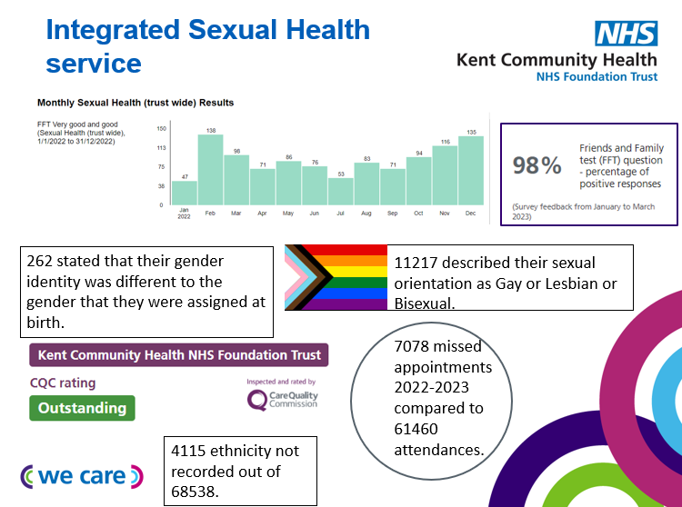  The Integrated Sexual Health service was selected as service number 1 where data indicates it is doing well. The rationale for this choice was based on the most recent CQC report in which the service was rated outstanding, a 98% positive response rate for the Friends and Family Test question scores and the service’s own data which showed that they were serving a wide range of people including many different protected characteristic groups.  Figure 3b One You smokefree  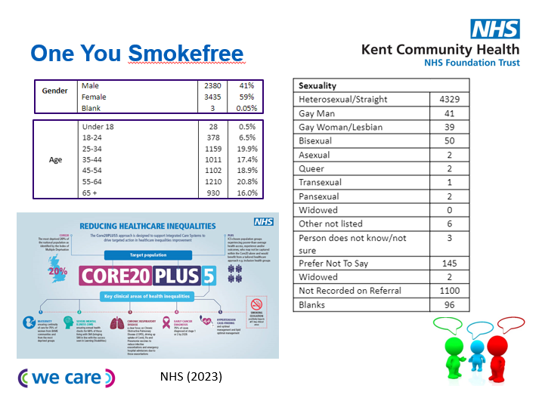  Figure 3c One You smokefree quit rates  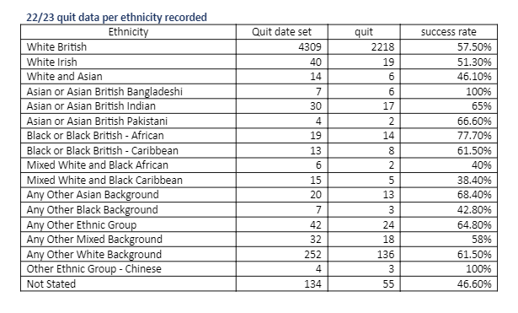  One You smokefree was selected as service 2 where data indicates that a service is not doing so well. When we were gathering evidence for service selection we did not identify any service where data really indicated that any service was not doing well per se. In fact, One You smokefree were performing well in regards to ethnicity and quit rates (see figure 3c). However, when we compared One You smokefree service data with local data around smoking rates, there were marked differences in expected breakdown of clients seen when compared to clients actually seen particularly around the characteristics of age, sexuality and gender. The Health Inequalities Team were also working with the service already as the service themselves had noted that they were seeing a much smaller proportion of clients who identify as LGBTQ+ than they would expect. Therefore, soft intelligence also informed our choice. Smoking cessation also positively impacts all five areas of the Core20PLUS5 approach which is a national NHS England approach to inform action to reduce healthcare inequalities at both national and system level. The service is also non-clinical. Therefore, we also felt that One You smokefree would bring balance to having two clinical services already and it would be helpful to consider how the work of the service is contributing to the national agenda around reducing healthcare inequalities.  Figure 3d Cardiac Rehabilitation Service  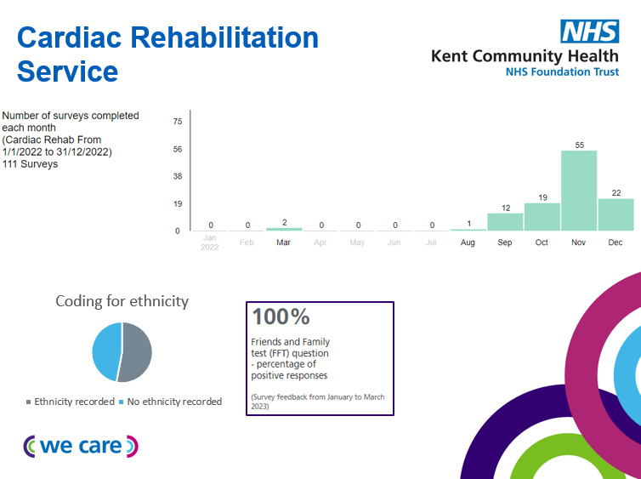  The Cardiac Rehabilitation service was selected as service number 3 where performance is unknown. The rationale for this choice was based predominantly on missing data especially around ethnicity recording identified through the HEA process and several months where there were no Friends and Family Test question scores recorded for the service.  Evidence gathered during the engagement phase  As mentioned earlier in this case study a multi method approach was used to plan engagement which generated a substantial amount of evidence against the four outcomes for Domain 1. This evidence was then supplemented by observations, e-mail feedback, photos, google listings (patient feedback), data and soft intelligence provided by staff across the three services (see figures 4a, 4b, 4c and 4d).  Evidence was uploaded onto an engagement log document that we created in Microsoft Excel. There were tabs for Domain 1 and Domain 2 to capture evidence against the outcomes.  Table 1: Engagement log: Tab for Domain 1  Heading Rationale  Reference This was helpful for coding responses as all engagement was anonymous. This was especially helpful when multiple patients or clients were interviewed in the same setting on the same date.  Date Date that evidence was collected or engagement took place.  Stakeholder Which service the staff member, patient, client or VCSE representative was referring to with their responses.  Number of people We included this to understand how common an opinion was which was helpful when feeding back to service leads.  Type of engagement Online surveys/1 to 1s/groups/e-mail etc. This was helpful to keep track of which methods were generating evidence.  Soft intelligence/context/observations We added this during the engagement phase as there was a lot of useful evidence gathered through observations and general information and resources shared by staff.  Do you feel that you/patients/service users have required levels of access to the service? To record responses around outcome 1a of Domain 1.  Do you feel that you/patients/service users health needs are met? To record responses around outcome 1b of Domain 1.  Do you feel that you/patients/service users have a positive experience of the service? To record responses around outcome 1c of Domain 1.  Have you ever experienced any mental or physical harm from using the service? To record responses around outcome 1d of Domain 1(not applicable for VCSE or staff survey completions).  Any follow up actions and person responsible We added this heading during the engagement phase as some points raised generated a number of actions.  We did not choose to include headings for responses to the equality monitoring questions as we did not want to add too much information to the engagement log. We were also only using this information to gain a sense as to whether we had engaged with a wide range of people from the local communities that we serve. For future applications of the Equality Delivery System (2022) we could include a tab with the equality monitoring information including postcodes or districts which could be used to help identify any underrepresented groups or areas within the engagement responses.  Once the evidence had been collated for each service a set of considerations and an action plan were formulated. Service leads were given a copy of the raw data and an individual service report of the findings, considerations and the action plan were presented to them. Service leads alongside the Health Inequalities Team scored their service against the four outcomes during this meeting. They also had the opportunity to add evidence to the action plan as it was clear during feedback that some actions had already been taken forward. The services were then sent the updated action plan and were informed that they could share the reports with teams once the final report had been through the governance process. The Health Inequalities Team have agreed a six-monthly review of action plans with services.  Figure 4a service 1 evidence: Integrated Sexual Health service  Figure 4b service 2 evidence: One You smokefree  Figure 4c service 3 evidence: Cardiac Rehabilitation service  Figure 4d  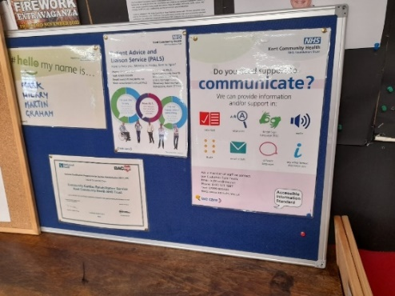  *Display board at exercise rehabilitation programme with information about reasonable adjustments, PALs details to pass on any feedback and names of staff and volunteers running the session on the day.
Have you identified any new sources of data and information?  What type of impact has this made? | (Full summaries of findings can be found within the main report for the Equality Delivery System (2022) for Kent Community Health NHS Foundation Trust).  For the Integrated Sexual Health service evidence showed that patient experience was predominantly positive and it was mainly due to technical issues when patient experience was not as positive. The service had already taken steps to rectify the issues. Inappropriate referrals and capacity were the most common issues raised by staff and again the service had already taken steps to address these. There are multiple ways to access the service and feedback has been positive for the Sexual health live chat especially for the d/Deaf community. The HIV peer support group was considered by patients to be innovative and the service experience of HIV patients was especially positive through being offered the same team of Nurses and Doctors and being able to contact clinical teams directly about concerns, appointments and medication. One new set of evidence which came from the VCSE survey completion was around the experience of ROMA communities using the service and issues with access due to a lack of interpreters and communications not being translated. The service leads had not heard this before especially as there are Outreach posts in place and were keen to take this forward to understand what could be done to help in future.  For One You smokefree health outcome data (see figure 3c) also indicates that service experience is good across at least one protected characteristic. For ethnicity, success rates were actually higher than the national average quit rate for NHS stop smoking services of 49-52% (NHS England, 2022) for all but 5 of the different ethnic groups. In addition, observations showed that every client had tailored advice around products, cravings and motivation to reflect different needs and lifestyles. All new clients were asked equality monitoring questions at their first appointment (a new implementation after acquiring the new client data system). Waiting times were mentioned by clients and not always being given information about how to get to physical sites. These were both already being actioned by the service. The main staff concerns were around waiting times and capacity and as such not being able to advertise the service more widely or complete targeted work. The service was already closely monitoring the situation and exploring new forms of marketing. The service leads gave feedback that it was really helpful to be able to see individual client comments as they don’t have the opportunity to drill down with feedback received usually. They were not aware that some appointment slots were being left empty by Advisers to offer to walk ins so this was new information and was actioned.  For the Cardiac Rehabilitation service patient experience was extremely positive with several patients commenting that they didn’t want to leave the service. There was one concern reported in regards to safety but following the presentation of findings to the service lead it became clear that this was due to a process not being followed by staff and so the likelihood of this issue reoccurring is low. Observations showed that information about reasonable adjustments, PALs and staff information were clearly displayed and that plans of care were individualised. The service could also meet a range of needs and patients were offered a “menu-based approach”. The main issues raised by patients were not always being clear about their support being individualised so not receiving the same support as other patients and lack of co-ordination from other health professionals and the service. The service had already taken steps to improve co-ordination with Hospitals and GPs in particular by passing across information about their service and referral pathways. Interpreting services were raised as the main concern by staff. One staff member also identified a significant gap in provision in the Thanet area but the service had already identified an innovative way of resolving this through implementation of a mobile app. The service lead was also offered further support from the Health Inequalities Team around support with finding suitable venues and the offer of the use of the Public Health Bus to reach people in more isolated or less well served areas.  Although the services assessed for Domain 1 offer different support they were all using innovative ways to provide better access, meet needs and improve experience for their patients and clients with a health equity approach focusing on offering choice and adaptability (see figure 4e). The impact that assessing the three services for Domain 1 has had is that it has shone a light on the significant work that has taken place towards creating an inclusive culture within these services for patients, clients and staff despite capacity, technology, resource and external challenges. For the Cardiac Rehabilitation Service, their data was also not showing the full picture so the Equality Delivery System (2022) evidence meant that the positive work could be showcased. The results for all three services have also identified ways in which wider trust services such as the Health Inequalities Team can help to work in partnership to address gaps, share good practice and provide reassurance that this work does not have to be the sole responsibility of the services themselves.  Figure 4e  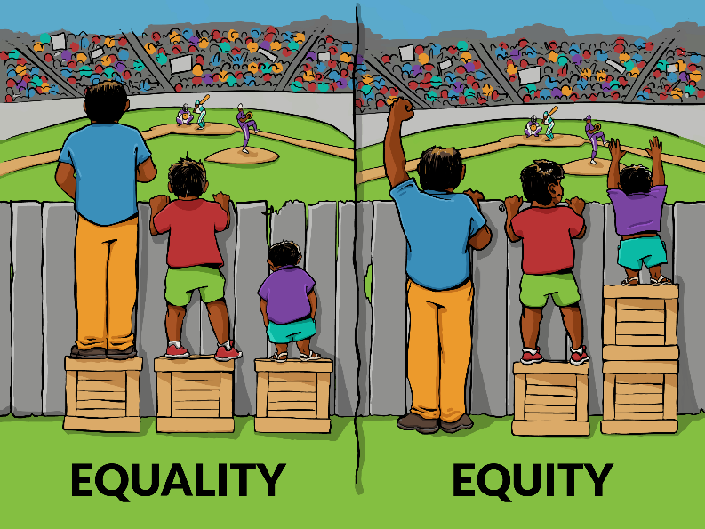  Interaction Institute for Social Change | Artist: Angus Maguire (2016)
Please provide any information on difficulties and/or barriers you experienced whilst collating evidence? | For the Cardiac Rehabilitation service there were gaps in the data. For instance, there were some months in which no Friends and Family test question responses had been received. The assumption was that patient experience surveys were not being given to patients or were not being completed. During the engagement phase it was mentioned that the surveys are usually given out as physical copies which are then returned to the Nurse once completed. The surveys are then uploaded to the system as and when the Administration Team have capacity to do so, often in bulk. It meant that the system couldn’t be viewed as a “live picture”. During the engagement phase we also observed some surveys being returned which were incomplete so would not be uploaded as you have to fill out all fields for the responses to be saved online.  For the Integrated Sexual Health service their service structure differed to that of the other two services due to different commissioning arrangements. In some parts of Kent, although still delivered by Kent Community Health NHS Foundation Trust, the service is commissioned to provide outreach events but not in others. There were also different procedures in place for data collection depending on which route into the service had been chosen for instance the Sexual Health live chat as they did not have a routine procedure around asking equality monitoring information compared to colleagues in clinic settings.  For the One You smokefree service there were some issues with data quality due to certain data codes historically used and missing equality monitoring data. The service already had taken steps to improve their data and had a new data system (Bionicle) in place. However, the decision to complete the Equality Delivery System (2022) work with the service was based on the last full year of data. Therefore, the data didn’t accurately reflect the cohort of clients being seen by the service during the engagement phase.
Please provide any other comments | For future applications of the Equality Delivery System (2022) we would:  - Consider inviting a patient, client or VCSE representative to hep with scoring services against the four outcomes for Domain 1.  - Ask services about their data collection processes in order to help acquire the best quality data to determine evidence base for possible selection.  - Consider a wide range of evidence alongside data especially if data systems have recently changed to better understand performance and inform decisions around service selection. This could include more local census data for example.  - Consider including responses to equality monitoring questions in the engagement log to ascertain during the engagement phase if there are any gaps in responses from geographical areas or there are additional groups we would like to engage with.  - Consider asking services in initial meetings ahead of the engagement phase about any action plans that currently exist around any other pieces of work such as the HEAs to determine if they are already aware of any gaps and any pre-escalated issues. This would help at the action plan formulation stage to know which actions are already taking place to avoid duplication.

Reference list
- Interaction Institute for Social Change (2016) Illustrating Equality VS Equity. Available at: Illustrating Equality VS Equity - Interaction Institute for Social Change : Interaction Institute for Social Change (Accessed: 29 December 2023).
- NHS England (2022) Statistics on NHS Stop Smoking Services in England-April 2021 to March 2022. Available at: Introduction - NHS Digital (Accessed: 16 February 2024).
- NHS England (2023) Core20PLUS5 (adults)-an approach to reducing healthcare inequalities. Available at: NHS England » Core20PLUS5 (adults) – an approach to reducing healthcare inequalities (Accessed: 29 December 2023).
- NHS England (2023) Equality Delivery System 2022. Available at: NHS England » Equality Delivery System 2022 (Accessed: 28 September 2023).
- NHS England (2023) National Patient and Staff Surveys. Available at: Statistics » National Patient and Staff Surveys (england.nhs.uk) (Accessed: 29 December 2023).
- Office for Health Improvement and Disparities (2023) Health equity audit guide for screening providers and commissioners. Available at: Health equity audit guide for screening providers and commissioners - GOV.UK (www.gov.uk) (Accessed: 27 December 2023).
- SurveyMonkey (2023) Get answers with surveys. Available at: SurveyMonkey - Free online survey software and questionnaire tool (Accessed: 29 December 2023).

Appendix

*EXAMPLE PATIENT/CLIENT SURVEY*

One You smokefree client survey

We are currently seeking feedback around patient/service user experience of One You smokefree as part of our work for the Equality Delivery System (2022) with the aim of improving the service we provide for our local communities. We would really value your feedback. All responses are anonymous.

Further information about the Equality Delivery System (2022) can be found here: https://www.england.nhs.uk/publication/equality-delivery-system-2022-guidance-and-resources/#reporting-template

- Do you feel that you have the required level of access to the service that you need and why?

- Do you feel that your health needs are met and why?

- Have you ever experienced any mental or physical harm from using the service? If so please can you tell us more.

- How do you feel about your experience of the service?

We would like to ask some questions about you. The information you provide will be used for statistical and research purposes only. If there are any questions you do not wish to answer, feel free to select prefer not to say.

- What is your age?
Under 18
18-24
25-34
35-44
45-54
55-64
65+
Prefer not to say

- What is your gender?
Female
Male
Other
Prefer not to say

- Is your gender identity the same as the gender identity you were assigned at birth?
Yes
No
Prefer not to say

- Which of the following best describes your sexual orientation?
Heterosexual/straight
Lesbian/gay
Bisexual
Other
Prefer not to say

- Please describe your ethnicity
White-British
White-Irish
White-Any other White background
Mixed-White and Black Caribbean
Mixed-White and Black African
Mixed-White and Asian
Mixed-Any other mixed background
Asian or Asian British-Indian
Asian or Asian British-Pakistani
Asian or Asian British-Bangladeshi
Asian or Asian British-Any other Asian background
Black or Black British-Caribbean
Black or Black British-African
Black or Black British-Any other Black background
Other Ethnic Groups-Chinese
Other Ethnic Groups-Any other ethnic group
Prefer not to say

- What is your marital status?
Single
Married
Living with partner
Other
Prefer not to say

- Do you consider yourself to have a disability or long term condition (including mental health)?
Yes
No
Prefer not to say

- What is your religion?
No religion
Christian
Buddhist
Hindu
Jewish
Muslim
Sikh
Other
Prefer not to say
- Are you pregnant or have you had a baby in the last 2 years?
Yes
No
Prefer not to say

If you would like to discuss anything that you have raised in this survey regarding any compliments, queries, concerns or complaints then you can contact the Patient Advice and Liaison Service using these contact details:
Telephone: 0800 030 4550
Text: 07899 903499
E-mail: kentchft.PALS@nhs.net
Or you can complete the online form here: PALS contact form (including Easy Read) | Kent Community Health NHS Foundation Trust (kentcht.nhs.uk)

*EXAMPLE STAFF SURVEY*

One You smokefree staff survey

We are currently seeking feedback around patient/service user experience of One You smokefree as part of our work for the Equality Delivery System (2022) with the aim of improving the service we provide for our local communities. We would really value your feedback. All responses are anonymous.

Further information about the Equality Delivery System (2022) can be found here: https://www.england.nhs.uk/publication/equality-delivery-system-2022-guidance-and-resources/#reporting-template

- Do you feel that clients have the required level of access to the service that they need and why?

- Do you feel that client’s health needs are met and why?

- Do you feel that clients have a positive experience of the service?

- Where if needed would you find information that would support you managing a long-term health condition or illness (including mental health)?

- Do you feel the trust promotes and provides innovative initiatives for work-life balance, healthy lifestyles, encourages and provides opportunity to exercise?

- What could the trust do to support colleagues with long-term health conditions/illness so they can manage their health and wellbeing better?

We would like to ask some questions about you. The information you provide will be used for statistical and research purposes only. If there are any questions you do not wish to answer, feel free to select prefer not to say.

- What is your age?
Under 18
18-24
25-34
35-44
45-54
55-64
65+
Prefer not to say

- What is your gender?
Female
Male
Other
Prefer not to say

- Is your gender identity the same as the gender identity you were assigned at birth?
Yes
No
Prefer not to say

- Which of the following best describes your sexual orientation?
Heterosexual/straight
Lesbian/gay
Bisexual
Other
Prefer not to say

- Please describe your ethnicity
White-British
White-Irish
White-Any other White background
Mixed-White and Black Caribbean
Mixed-White and Black African
Mixed-White and Asian
Mixed-Any other mixed background
Asian or Asian British-Indian
Asian or Asian British-Pakistani
Asian or Asian British-Bangladeshi
Asian or Asian British-Any other Asian background
Black or Black British-Caribbean
Black or Black British-African
Black or Black British-Any other Black background
Other Ethnic Groups-Chinese
Other Ethnic Groups-Any other ethnic group
Prefer not to say

- What is your marital status?
Single
Married
Living with partner
Other
Prefer not to say

- Do you consider yourself to have a disability or long term condition (including mental health)?
Yes
No
Prefer not to say

- What is your religion?
No religion
Christian
Buddhist
Hindu
Jewish
Muslim
Sikh
Other
Prefer not to say
- Are you pregnant or have you had a baby in the last 2 years?
Yes
No
Prefer not to say

Equality Delivery System (2022) information sheet

What is EDS (2022)?
The Equality Delivery System (EDS) 2022 is a system that helps NHS Organisations improve the services they provide for their local communities and provide better working environments free of discrimination for those who work in the NHS whilst meeting the requirements of the Equality Act 2010. For more information, please read here: NHS England » Equality Delivery System 2022

Service choice
We have chosen 3 services across KCHFT to take part in EDS for this year, those services are:
- One You smokefree
- Integrated Sexual Health
- Cardiac Rehab

What does this mean for me?
For each service we will be looking to engage with patients /service users to find out their experience of the service and we will also be speaking to KCHFT colleagues about how they feel that their patients / service users experience the service.

We are seeking your feedback throughout September via this survey link about one of the services in order that we can better understand your experience: https://eu.surveymonkey.com/r/FQY3WT9. We will also be asking staff from the three services and representatives from the Voluntary, Community and Social Enterprise sector for their feedback.

At the end of the process the service will be rated against the self-assessment framework and then the Trust is centrally rated against all 3 services in a single score. This is then published on the external KCHFT website in February, after going through the internal governance process. We will also feedback to your service about any individual service findings.

